Sequence Diagram:

Profile Page Update:
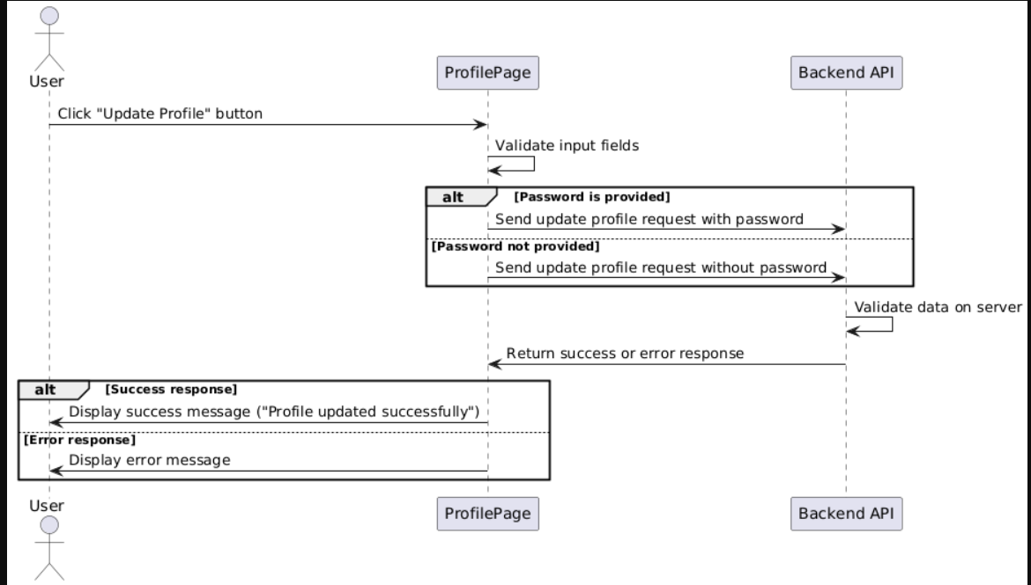

Functional Requirements (FRs)
Profile Update Process
FR1: The system shall allow users to click the "Update Profile" button to initiate the update process.
FR2: The backend API shall validate the provided data before updating the profile.
FR3: The backend API shall return a success response if the update is successful.
FR4: The backend API shall return an error response if validation fails or an issue occurs.
FR5: The frontend shall display a success message upon a successful profile update.

Non-Functional Requirements (NFRs)
Performance & Reliability
- NFR1: The profile update request should be processed within 2 seconds for a smooth user experience.
- NFR2: The system should handle 100+ concurrent profile update requests without performance degradation.
Usability
- NFR3: The user interface shall provide clear error messages in case of validation failures.
- NFR4: The profile update page shall be responsive and work on both desktop and mobile devices.
Availability
- NFR5: The system shall have 99.9% uptime, ensuring that profile updates are always accessible.

